

Information Technology College (ITC)
Digital Egypt Pioneers Initiative (DEPI)

GRADUATION PROJECT DOCUMENTATION REPORT

E-Learning Platform
React.js Front-End Development Track

Prepared By

Omar Ahmed Abdalal Mohamed
Omar Khaled Mansour Elsayed
Ali Khaled Mohamed Ali
Mahmoud Mohamed Abdel-Hadi Mohamed
Aya Ahmed Hassan Mustafa

Track: React.js Front-End Development
Year: 2026

Table of Contents

Executive Summary
The E-Learning Platform is a modern, fully responsive front-end web application developed using React.js as the final graduation project for the React.js Front-End Development track under the Information Technology College (ITC) in partnership with the Digital Egypt Pioneers Initiative (DEPI). The platform was designed and built to simulate a real-world online learning environment, allowing learners to explore courses, browse instructor profiles, read educational content, and interact with a complete authentication system.
The purpose of the project is to demonstrate the team's practical mastery of front-end engineering principles, including component-based architecture, client-side routing, responsive layout design, and integration with third-party services such as EmailJS for communication features. The platform was conceived, designed, and implemented entirely by the team across multiple development phases, from wireframing and UI design to component development, testing, and deployment.
The target users of the platform are students and lifelong learners seeking flexible, self-paced access to educational content, as well as instructors who wish to showcase their courses and expertise. The platform is also intended to serve as a portfolio-grade demonstration project that highlights the team's ability to deliver a production-ready front-end application.
The expected benefits of the E-Learning Platform include providing learners with a centralized, accessible, and user-friendly environment for digital education, demonstrating the practical application of React.js concepts learned during the DEPI training program, and establishing a strong foundation that can be extended with backend services, authentication, and payment systems in future iterations.

Project Overview

What the Platform Is
The E-Learning Platform is a single-page application (SPA) built with React.js that offers a complete front-end experience for an online education service. It includes a home page, an about us page, a courses catalog, login and registration pages, a contact page, and a frequently asked questions (FAQ) page, all connected through a unified navigation system.

Why It Was Developed
The project was developed as the capstone deliverable for the DEPI React.js Front-End Development track. It was created to consolidate the technical skills acquired throughout the training program, including component design, state management, routing, and responsive UI development, into a single cohesive product that mirrors the structure of real commercial e-learning platforms such as Udemy and Coursera.

Main Objectives
- Build a fully responsive, multi-page React.js application using modern front-end practices.
- Implement a clean and reusable component architecture that promotes maintainability.
- Design an intuitive user interface that supports course discovery and user engagement.
- Integrate third-party services such as EmailJS to enable real communication functionality.
- Deploy the application to a live, publicly accessible environment using Vercel.

Target Audience
The platform targets students of varying educational backgrounds who are interested in flexible online learning, as well as instructors and content creators who wish to showcase their courses. It is also relevant to recruiters and technical evaluators reviewing the team's graduation project as part of the DEPI assessment process.

Educational Benefits
By using the platform, learners gain the ability to browse a structured catalog of courses across multiple categories, view instructor credentials, read testimonials from other learners, and access support through the FAQ and contact sections, all of which contribute to an informed and confident learning decision-making process.

Project Idea
The idea behind the E-Learning Platform stems from the growing global shift toward digital and remote education. Traditional classroom-based learning is increasingly being complemented, and in many cases replaced, by online platforms that allow learners to study at their own pace, from any location, and according to their own schedule.

Online Education Importance
Online education has become a cornerstone of modern learning ecosystems, enabling access to high-quality instructional content without the geographical and financial constraints of traditional institutions. The E-Learning Platform reflects this trend by offering a digital-first learning experience accessible from any device.

Accessibility
The platform was designed with accessibility in mind, ensuring that the interface adapts smoothly across desktop, tablet, and mobile devices. This allows learners from diverse backgrounds and with varying levels of access to technology to use the platform comfortably.

Self-Paced Learning
A key principle behind the platform's design is enabling self-paced learning, where users can browse, select, and engage with course content according to their own availability rather than being bound by fixed class schedules.

Digital Transformation in Education
The project also reflects the broader digital transformation taking place in the education sector, where institutions and independent educators are migrating their content and services to online platforms to reach wider audiences and provide more flexible learning pathways.

Problem Statement
Despite the growing availability of online educational content, many learners continue to face significant challenges when trying to access organized, reliable, and centralized learning resources. The E-Learning Platform was conceived to directly address these pain points.

Key Problems Faced by Learners
- Difficulty finding organized learning resources scattered across multiple unrelated websites and sources.
- Lack of a centralized educational platform that brings together courses, instructors, and support resources in one place.
- Limited flexibility in traditional learning environments that rely on fixed schedules and physical attendance.
- Access limitations caused by geographic location, device compatibility, or lack of responsive design on existing platforms.

How the E-Learning Platform Solves These Issues
The platform addresses these problems by providing a single, centralized, and fully responsive interface where learners can browse courses by category, view detailed instructor profiles, read reviews and testimonials, and reach support easily through a dedicated contact and FAQ system. By consolidating these features into one cohesive application, the platform removes the friction typically associated with fragmented online learning resources.

Technologies Used
The E-Learning Platform was built using a modern front-end technology stack centered around React.js. The following table summarizes the core technologies used in the project, along with their purpose, advantages, and specific role within the application.

Technology | Purpose | Advantages | How It Was Used
React.js | Core front-end library for building the user interface | Component reusability, virtual DOM performance, large ecosystem | Used to build all pages and reusable UI components across the platform
JavaScript (ES6) | Programming language powering application logic | Modern syntax, arrow functions, destructuring, modules | Used for state handling, event logic, and data manipulation throughout the app
HTML5 | Markup structure of the application | Semantic elements, accessibility, SEO friendliness | Used within JSX to structure every page and component
CSS3 | Styling and visual presentation | Flexbox, Grid, animations, responsive media queries | Used to style components and implement the responsive layout system
React Router | Client-side routing between pages | Seamless navigation without full page reloads | Used to manage navigation between Home, About, Courses, Login, Register, Contact, and FAQ pages
EmailJS | Sending emails directly from the front-end | No backend server required for basic contact functionality | Integrated into the Contact Us form to send messages from users
Git | Version control system | Tracks changes, supports branching and collaboration | Used by all team members to manage code versions throughout development
GitHub | Remote repository hosting | Centralized collaboration, pull requests, issue tracking | Used to host the project repository and coordinate teamwork
Vercel | Deployment and hosting platform | Fast, free, automatic deployment from GitHub | Used to deploy the final application to a live public URL

Project Features

Responsive Design
The platform automatically adapts its layout, typography, and component arrangement to fit desktop, tablet, and mobile screens, ensuring a consistent experience across all devices.

Modern UI/UX
The interface follows modern design principles, including clean typography, consistent color theming, soft rounded components, and clear visual hierarchy to guide users naturally through the platform.

Course Browsing
Users can explore a catalog of courses organized by category, including Design, Development, Business, Marketing, Animation, and Interaction, with each course presented as a card containing key details.

User Authentication Pages
Dedicated Login and Registration pages allow users to create accounts and sign in, including options to authenticate via Google or Facebook for a streamlined onboarding experience.

FAQ System
An expandable, searchable FAQ section helps users quickly find answers to common questions about certificates, refunds, course pacing, and account access.

Contact Form
A fully functional contact form, integrated with EmailJS, allows users to send messages directly to the platform's support team without requiring a backend server.

Instructor Showcase
The platform highlights tutors and instructors, building trust and credibility by presenting their expertise alongside the courses they teach.

Blog Section
A blog area on the home page provides supplementary educational articles and updates, enriching the overall content experience for learners.

Testimonials
Testimonials from past learners are displayed to build social proof and demonstrate the value and quality of the platform's educational offerings.

Navigation System
A persistent top navigation bar provides quick access to Home, About Us, Courses, Contact Us, and FAQ pages, along with Sign In and Create Free Account actions.

System Architecture

Components Structure
The application follows a component-based architecture typical of React.js projects, where the UI is broken down into small, reusable building blocks such as Navbar, Footer, CourseCard, TestimonialCard, and FAQItem. Each component encapsulates its own logic and styling, making the codebase easier to maintain and extend.

Pages Structure
The platform is organized into distinct page-level components, including Home, About Us, Courses, Login, Register, Contact Us, and FAQ. Each page composes multiple smaller components together to form the complete user experience.

Assets Management
Static assets such as images, icons, and logos are organized within a dedicated assets directory, allowing components to import and reference them consistently throughout the application.

Routing System
React Router is used to manage navigation between pages without triggering full page reloads, providing a smooth single-page application experience while maintaining clean, readable URLs for each section.

Styling System
Styling is implemented primarily through CSS3, using Flexbox and Grid layouts to achieve responsive, well-aligned page structures, along with consistent color variables and typography scales applied across components.

Reusable Components
Reusable components, such as buttons, cards, and form inputs, are designed to accept props that customize their content and behavior, reducing code duplication and ensuring visual consistency across the entire platform.

Screenshots and System Pages
This section presents a complete visual walkthrough of the E-Learning Platform's user interface. Each screenshot is accompanied by a figure number, a descriptive title, and a structured explanation covering its description, purpose, main components, available user actions, and the benefits it provides to the end user.

Home Page Section
The Home Page serves as the main entry point of the platform, welcoming visitors with a hero banner, key platform statistics, and quick access to the primary navigation. It is designed to immediately communicate the platform's value proposition and encourage visitors to explore courses or create an account.

1. Home Page – Hero and Statistics Section
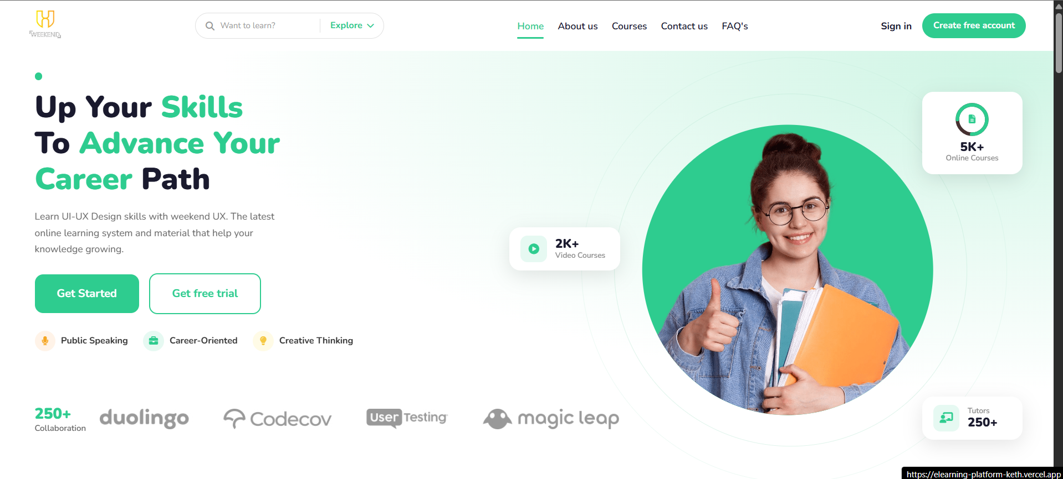
Figure 1: Home Page – Hero and Statistics Section
Description: This screenshot shows the top section of the Home Page, including the main navigation bar, the hero banner with the headline “Up Your Skills To Advance Your Career Path,” a supporting description, two call-to-action buttons, and a set of trust indicators including platform statistics and partner logos.
Purpose: To immediately introduce visitors to the platform's purpose, highlight its credibility through statistics and partner branding, and direct users toward the next step, whether signing up or browsing courses.
Main Components:
- Top navigation bar with Home, About Us, Courses, Contact Us, and FAQ links
- Sign In and Create Free Account buttons
- Hero headline and supporting paragraph
- Get Started and Get Free Trial call-to-action buttons
- Skill tags: Public Speaking, Career-Oriented, Creative Thinking
- Statistic cards showing 5K+ Online Courses, 2K+ Video Courses, and 250+ Tutors
- Partner/brand logo strip (Duolingo, Codecov, UserTesting, Magic Leap)
User Actions:
- Click Get Started or Get Free Trial to begin onboarding
- Use the search bar to look for a specific topic
- Navigate to other pages using the top navigation bar
- Click Sign In or Create Free Account to access authentication
Benefits:
- Provides a strong first impression that builds user trust
- Clearly communicates the platform's scale and credibility through statistics
- Offers immediate, clear pathways for new and returning users

Search Section
Integrated directly into the navigation bar, the search functionality allows users to quickly look up topics or courses of interest using the “Want to learn?” search field paired with an Explore dropdown, enabling fast content discovery from any page on the platform.

Statistics Section
As shown in Figure 1, the statistics section displays key platform metrics, including the number of available online courses, video courses, and tutors, reinforcing the platform's scale and encouraging user confidence.

Learning Services Section
Below the hero area, the Home Page continues with a learning services section that outlines the core categories of skills offered on the platform, helping users quickly identify the type of content most relevant to their goals.

Popular Courses Section
The Home Page features a curated selection of popular courses, presented as visually rich cards with thumbnail images, duration badges, and category labels, giving users a quick preview of trending content before navigating to the full Courses page.

Tutors Section
A dedicated tutors section showcases the platform's instructors, presenting their names, specialties, and photos to build credibility and help learners feel confident in the quality of instruction available.

Testimonials Section
The testimonials section displays feedback from past learners, reinforcing social proof and demonstrating the real-world value and satisfaction associated with using the platform.

Blog Section
A blog section presents recent articles and educational updates, adding ongoing value to visitors beyond the core course catalog and encouraging repeat visits to the platform.

Footer Section
The footer, consistent across all pages, provides quick links, contact information, and social media icons, ensuring users always have access to essential platform information regardless of which page they are viewing.

About Us Page
The About Us page communicates the platform's mission, vision, and value proposition to visitors, helping build trust and explaining the purpose behind the E-Learning Platform.

2. About Us Page – Mission and Vision Section
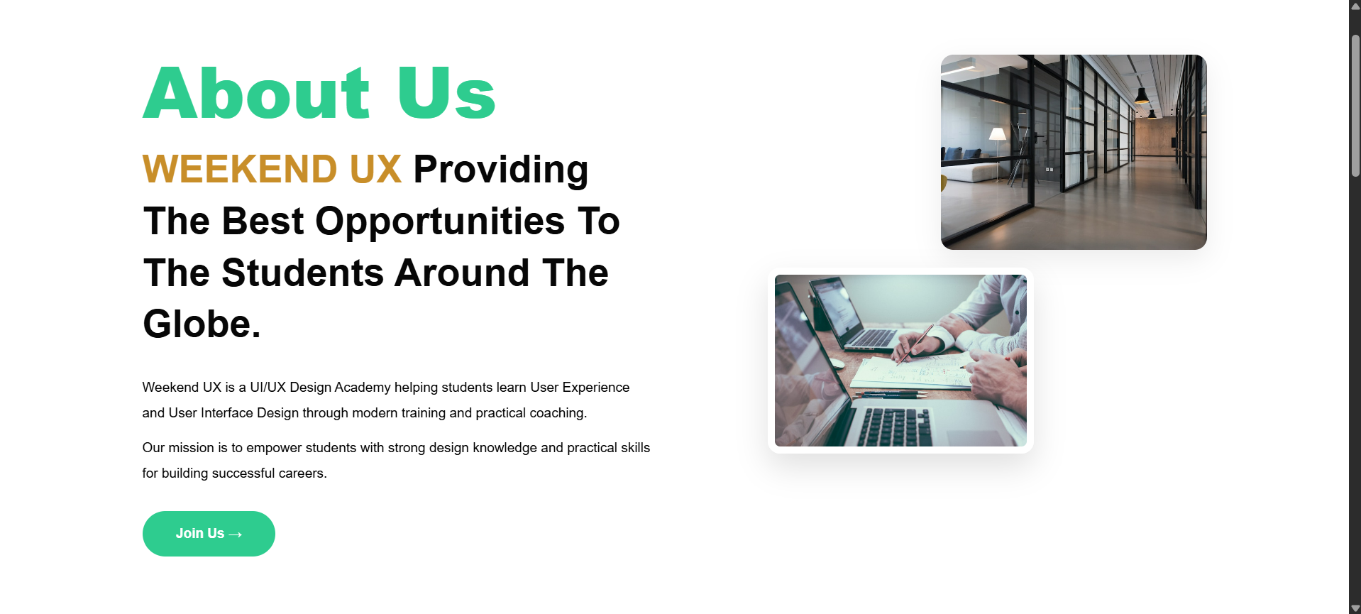
Figure 2: About Us Page – Mission and Vision Section
Description: This screenshot displays the About Us page, featuring a bold headline introducing the platform's brand identity, a descriptive mission statement, supporting imagery of a modern office and collaborative work environment, and a Join Us call-to-action button.
Purpose: To communicate the platform's mission and vision to visitors, building trust and explaining why the platform was created and what it aims to achieve for its learners.
Main Components:
- About Us section headline and brand introduction
- Mission statement paragraph describing the academy's purpose
- Supporting descriptive text about empowering students
- Two supporting images depicting a professional office and a collaborative work session
- Join Us call-to-action button
User Actions:
- Read the mission and vision statement
- Click Join Us to proceed toward account creation
- Continue scrolling to view additional Features and Benefits sections
Benefits:
- Builds credibility and trust with prospective learners
- Clearly communicates the platform's purpose and values
- Encourages visitors to take the next step toward joining the platform

Features Section
Following the mission statement, the About Us page continues with a features section that highlights what differentiates the platform, such as expert-led courses, flexible learning, and a supportive learning community.

Benefits Section
The page concludes with a benefits section outlining the tangible advantages learners gain by choosing the platform, reinforcing the value proposition introduced earlier on the page and on the Home Page.

Courses Page
The Courses page is the central catalog of the platform, allowing users to browse, filter, and explore all available courses across multiple categories.

3. Courses Page – Browse Catalog Section
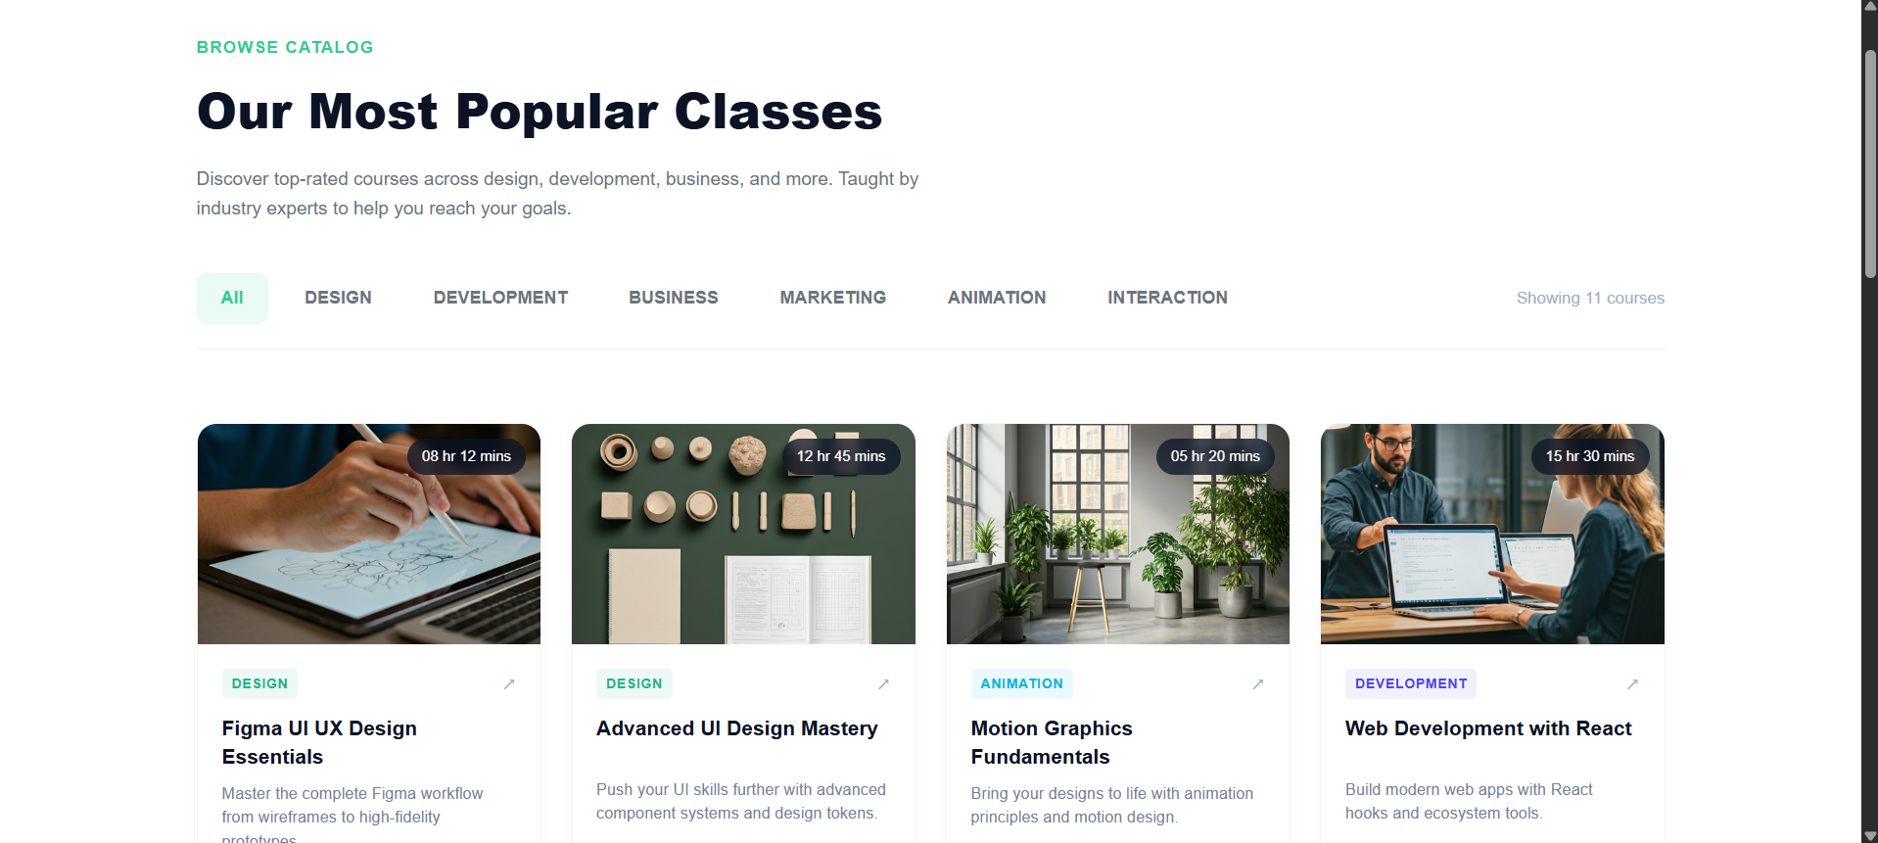
Figure 3: Courses Page – Browse Catalog Section
Description: This screenshot shows the Courses page displaying the heading “Our Most Popular Classes,” a category filter bar (All, Design, Development, Business, Marketing, Animation, Interaction), and a responsive grid of course cards, each containing a thumbnail image, duration badge, category tag, title, and short description.
Purpose: To allow learners to browse the full course catalog, filter by category, and quickly assess course details before deciding to enroll or learn more.
Main Components:
- Page heading and descriptive subtext
- Category filter tabs for narrowing the course list
- Course count indicator (e.g., “Showing 11 courses”)
- Course cards featuring thumbnail image, duration badge, category label, and title
- Short course description beneath each card title
User Actions:
- Filter courses by selecting a category tab
- Click on a course card to view more details
- Scroll through the catalog to browse all available courses
Benefits:
- Simplifies course discovery through clear categorization
- Presents essential course information at a glance
- Encourages exploration through an organized, visually engaging grid layout

Course Categories
The category filter bar enables users to instantly narrow the displayed courses to a specific domain, such as Design, Development, Business, Marketing, Animation, or Interaction, streamlining the browsing experience.

Course Listing
The course listing area dynamically displays all courses matching the selected category, organized in a responsive grid that adjusts based on screen size.

Course Cards
Each course card communicates ratings, instructor association, pricing context, and category through concise visual elements, allowing users to interact with the card to access full course details, ratings, and instructor information.

Login Page
The Login page provides registered users with secure access to their accounts through a clean, split-screen design pairing an inspirational classroom image with the authentication form.

4. Login Page – User Authentication Form
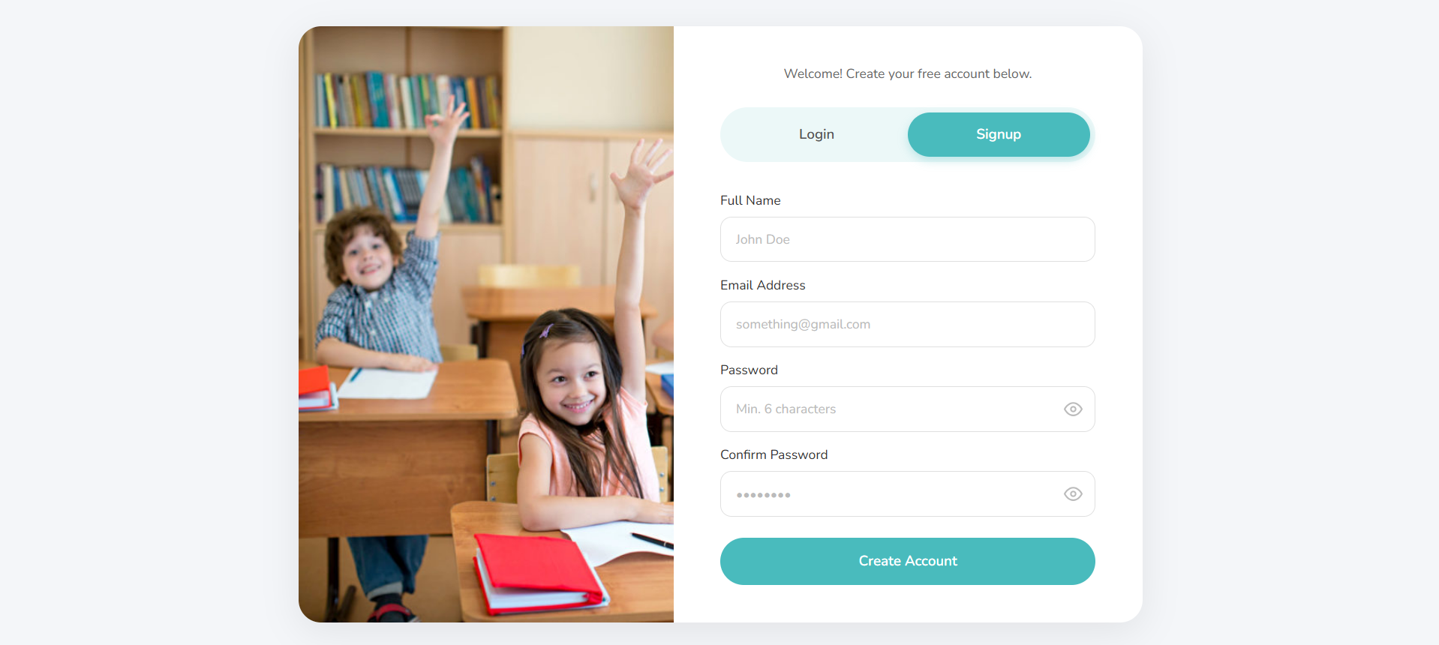
Figure 4: Login Page – User Authentication Form
Description: This screenshot shows the Login page, featuring a classroom photograph on the left side and an authentication form on the right side, including a welcome message, Login/Signup toggle tabs, email and password fields, a Remember Me checkbox, a Forgot Password link, a primary Login button, and social login options for Google and Facebook.
Purpose: To allow returning users to securely access their accounts using their registered credentials or through third-party social login providers.
Main Components:
- Welcome back message
- Login / Signup toggle tabs
- Email Address input field
- Password input field with show/hide toggle icon
- Remember Me checkbox
- Forgot Password link
- Primary Login button
- Login with Google and Login with Facebook buttons
User Actions:
- Enter email address and password to log in
- Toggle the password visibility icon to verify input
- Check Remember Me to stay signed in
- Click Forgot Password to begin account recovery
- Use Google or Facebook buttons for social login
- Switch to the Signup tab to create a new account
Benefits:
- Provides a fast, secure, and familiar login experience
- Reduces friction through social login alternatives
- Improves usability with password visibility and remember-me options

Register Page
The Register page allows new visitors to create a free account, collecting the essential information needed to set up a learner profile.

5. Register Page – Account Creation Form
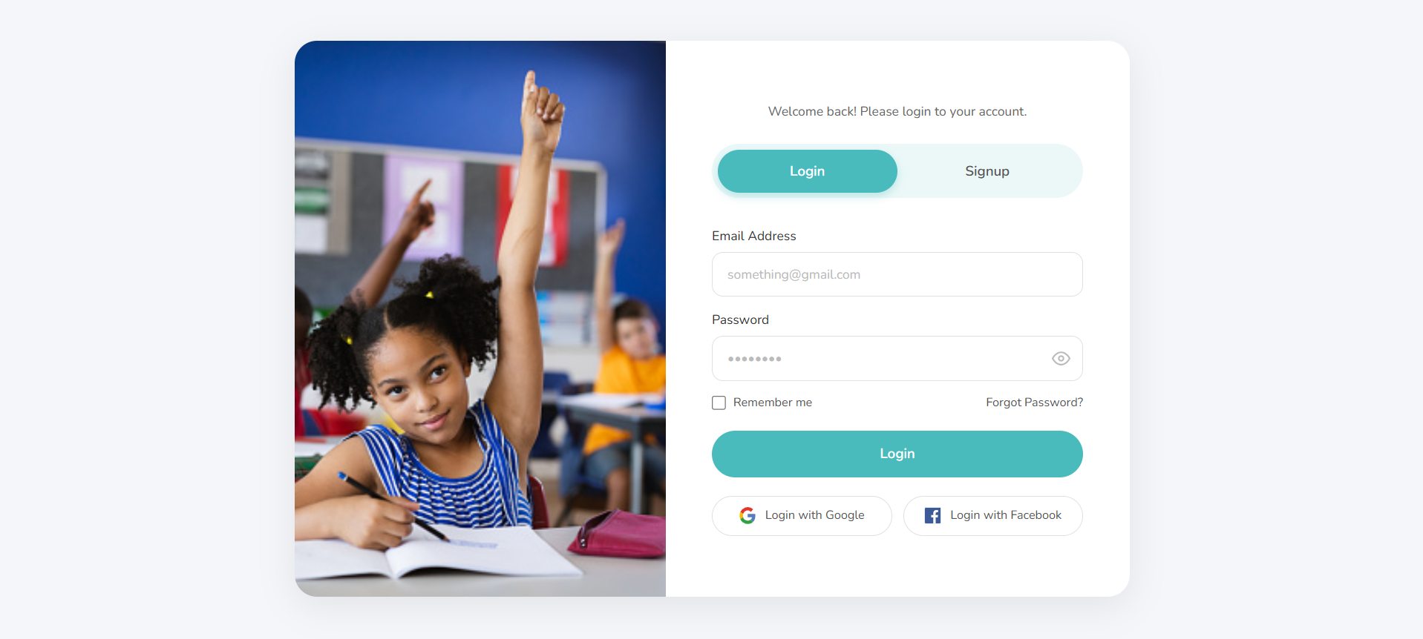
Figure 5: Register Page – Account Creation Form
Description: This screenshot shows the Register page, presenting the same split-screen design as the Login page, with a classroom photograph on the left and a registration form on the right containing fields for Full Name, Email Address, Password, and Confirm Password, along with a prominent Create Account button.
Purpose: To collect the necessary information from new users in order to create a personal learner account on the platform.
Main Components:
- Welcome message inviting users to create a free account
- Login / Signup toggle tabs
- Full Name input field
- Email Address input field
- Password input field with minimum character guidance and visibility toggle
- Confirm Password input field with visibility toggle
- Create Account button
User Actions:
- Fill in full name, email, and password fields
- Confirm the password to ensure accuracy
- Click Create Account to submit the registration form
- Switch to the Login tab if an account already exists
Benefits:
- Streamlines the account creation process for new learners
- Provides clear input guidance, such as minimum password length
- Maintains visual consistency with the Login page for a cohesive user experience

Contact Us Page
The Contact Us page enables users to reach the platform's support team directly through an integrated contact form, while also displaying organizational contact details and location information.

6. Contact Us Page – Contact Form Section
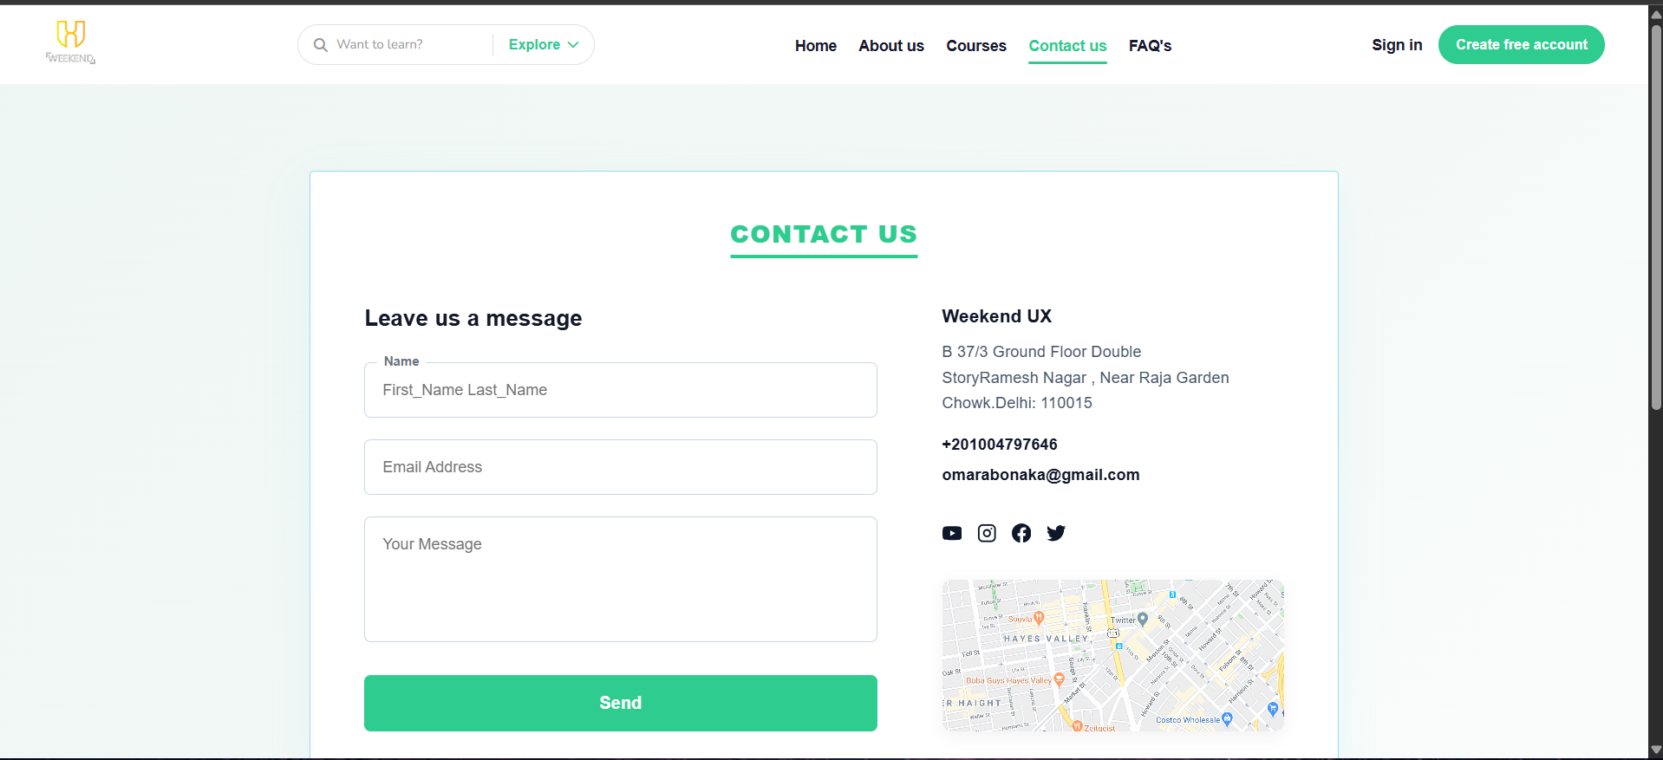
Figure 6: Contact Us Page – Contact Form Section
Description: This screenshot shows the top of the Contact Us page, including the main navigation bar with the Contact Us link highlighted as active, the page heading “Contact Us,” a “Leave us a message” form with Name, Email Address, and Message fields, a Send button, and the organization's contact details, social icons, and a map preview on the right side.
Purpose: To provide users with a direct communication channel for inquiries, support requests, or feedback regarding the platform.
Main Components:
- Active Contact Us navigation indicator
- Page heading and section title
- Contact form with Name, Email Address, and Message fields
- Send button
- Organization name, address, phone number, and email
- Social media icons (YouTube, Instagram, Facebook, Twitter)
- Embedded map preview
User Actions:
- Fill in the contact form and click Send to submit a message
- Click a social media icon to visit the platform's social profile
- View the embedded map to locate the organization
Benefits:
- Provides a simple, accessible way for users to reach support
- Builds trust by displaying transparent contact information
- Consolidates communication channels into a single, organized page

7. Contact Us Page – Social Links and Map Section
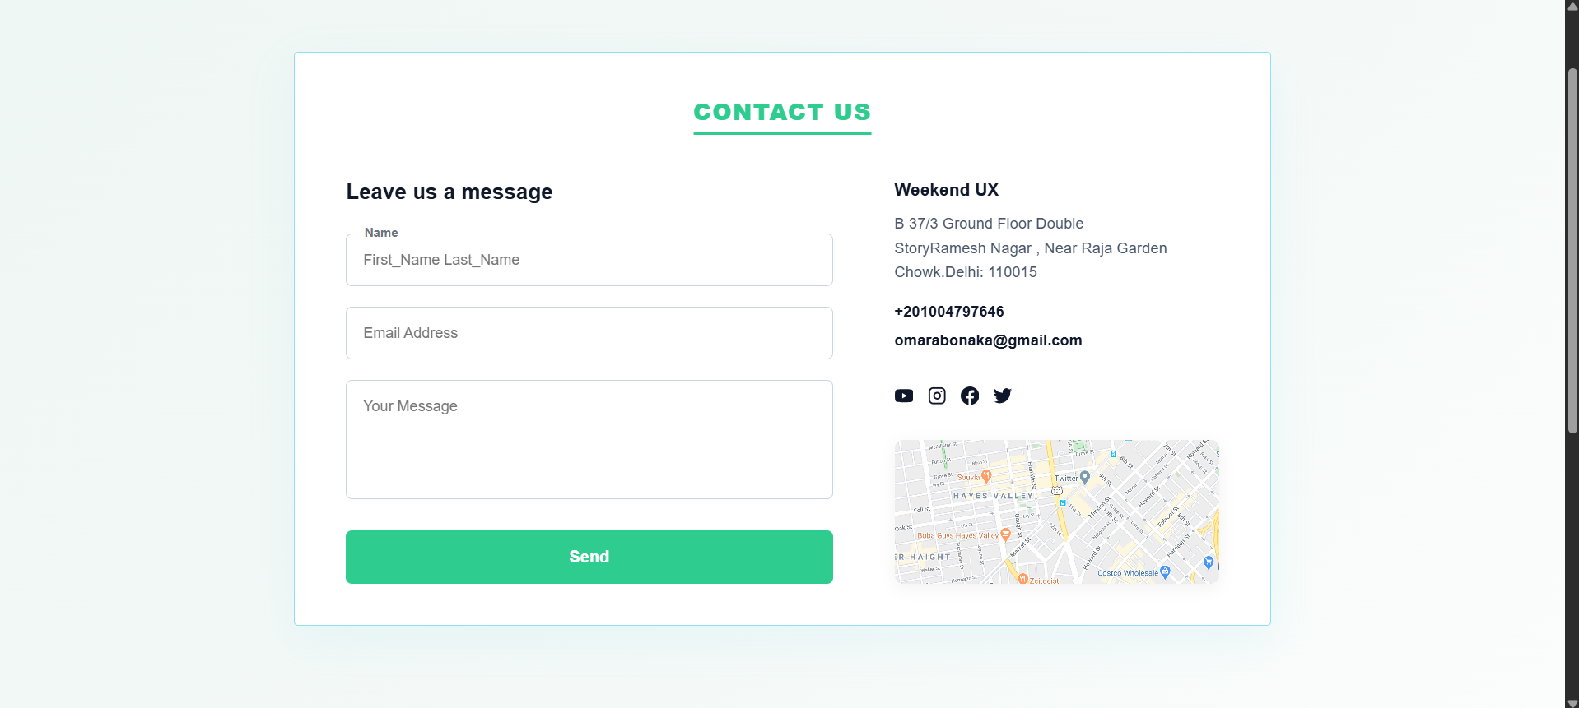
Figure 7: Contact Us Page – Social Links and Map Section
Description: This screenshot presents a closer view of the lower portion of the Contact Us form area, clearly displaying the organization's address, phone number, email address, social media icon row, and the embedded interactive map used to indicate the organization's physical location.
Purpose: To reinforce trust and accessibility by clearly presenting alternative contact channels and a visual location reference alongside the contact form.
Main Components:
- Leave us a message form fields and Send button
- Organization address and contact details
- Social media icon row
- Embedded map showing the organization's location
User Actions:
- Use the social icons to connect with the platform on social media
- Reference the map for the organization's physical location
- Submit the message form for direct inquiries
Benefits:
- Offers multiple channels of communication beyond the contact form
- Improves transparency and credibility through verifiable contact details
- Enhances user confidence when reaching out to the platform

FAQ Page
The FAQ page provides a self-service support resource, allowing users to quickly find answers to common questions without needing to contact the support team directly.

8. FAQ Page – Support Center Section
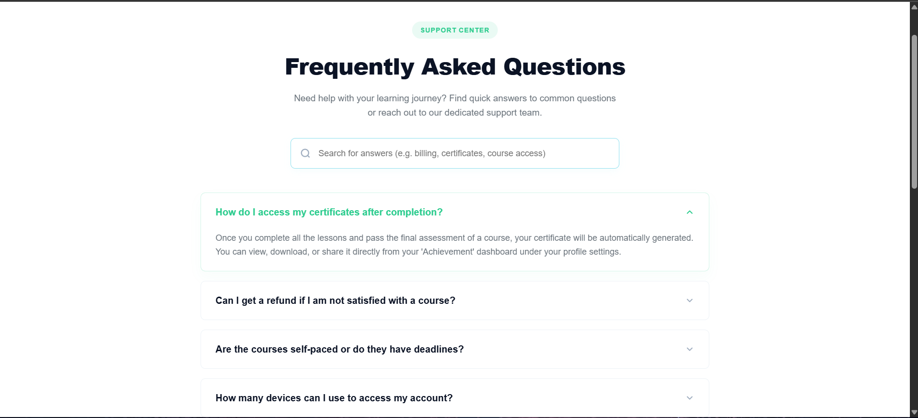
Figure 8: FAQ Page – Support Center Section
Description: This screenshot shows the FAQ page, featuring a “Support Center” label, the heading “Frequently Asked Questions,” a descriptive subtext, a search bar for finding answers, and a list of expandable question cards, with the first question, “How do I access my certificates after completion?” shown expanded with its full answer visible.
Purpose: To help users quickly find answers to common questions about certificates, refunds, course pacing, and account access without needing direct support contact.
Main Components:
- Support Center label and page heading
- Descriptive subtext explaining the purpose of the page
- Search bar for finding answers by keyword
- Expandable FAQ question cards with up/down toggle icons
- Expanded answer text for the active question
User Actions:
- Type a keyword into the search bar to filter questions
- Click a question card to expand or collapse its answer
- Scroll through the list to browse all available questions
Benefits:
- Reduces support workload by enabling self-service answers
- Improves user experience through quick access to relevant information
- Organizes support content in a clear, expandable format

Challenges and Solutions
Throughout the development of the E-Learning Platform, the team encountered a number of technical and design challenges typical of a real-world front-end project. The following section documents these challenges along with the causes, solutions implemented, and final outcomes.

1. Responsive Design Challenges
Problem: Several page layouts, particularly the course grid and the authentication pages, appeared misaligned or broken on smaller screen sizes.
Cause: Initial styling relied on fixed pixel widths rather than flexible layout units, which did not scale well across different viewport sizes.
Solution: The team refactored the CSS using Flexbox and CSS Grid combined with relative units and media queries to ensure layouts adjusted fluidly across breakpoints.
Result: The platform now renders correctly and consistently across desktop, tablet, and mobile devices.

2. Navigation and Routing Challenges
Problem: Some page transitions caused the active navigation link to not update correctly, and direct URL access to certain pages occasionally failed.
Cause: Route configuration was initially incomplete and the active link styling was not properly synchronized with React Router's location state.
Solution: The team restructured the route definitions and used React Router's NavLink component to automatically reflect the active page in the navigation bar.
Result: Navigation between all pages now works reliably, with the active page clearly highlighted in the navigation bar.

3. Component Reusability Challenges
Problem: Early versions of the project contained duplicated code across similar UI elements, such as course cards and testimonial cards.
Cause: Components were initially built individually for each page without considering shared structure or reusable props.
Solution: The team refactored shared UI elements into reusable, prop-driven components that could be reused across the Home and Courses pages.
Result: Code duplication was significantly reduced, improving maintainability and consistency across the application.

4. EmailJS Integration Challenges
Problem: The Contact Us form initially failed to send messages successfully, with errors occurring during the submission process.
Cause: Incorrect configuration of the EmailJS service ID, template ID, and public key prevented successful API calls.
Solution: The team carefully reconfigured the EmailJS service following official documentation and added proper error handling and success feedback for users.
Result: The Contact Us form now reliably sends messages and provides clear feedback to the user upon submission.

5. Deployment Challenges on Vercel
Problem: The initial deployment to Vercel resulted in broken routing, where refreshing a page other than the home page returned a not-found error.
Cause: The deployment configuration did not account for client-side routing requirements of a single-page application.
Solution: The team configured the appropriate routing rules for the Vercel deployment to ensure all routes correctly redirect to the React application entry point.
Result: The platform now deploys successfully on Vercel with all routes accessible directly and upon page refresh.

6. UI Consistency Challenges
Problem: Some pages exhibited inconsistent spacing, font sizes, and color usage compared to others, reducing the overall visual cohesion of the platform.
Cause: Styling decisions were initially made independently by different team members without a shared design system.
Solution: The team established consistent color variables, typography scales, and spacing conventions, then applied them uniformly across all pages and components.
Result: The platform now presents a unified, professional visual identity across every page.

Future Enhancements
While the current version of the E-Learning Platform successfully delivers a complete front-end experience, the team has identified a number of enhancements that would extend its functionality into a full-stack production-ready product.
- Firebase Authentication: Replace static authentication pages with real, secure user authentication and session management.
- Student Dashboard: Provide learners with a personalized dashboard to track enrolled courses and progress.
- Instructor Dashboard: Allow instructors to manage their own courses, content, and student interactions.
- Course Enrollment System: Implement a functional enrollment flow connecting users to specific courses.
- Certificates System: Automatically generate and issue completion certificates to learners.
- Payment Gateway Integration: Enable secure payment processing for paid courses and subscriptions.
- Progress Tracking: Track and visually display learner progress through course content.
- Notifications: Introduce a notification system to keep users informed of updates and announcements.
- Dark Mode: Add a dark theme option to improve accessibility and user comfort.
- AI-Based Recommendations: Suggest relevant courses to users based on their interests and learning history.

Project Achievements
- Successfully implemented a complete multi-page application using React.js and modern front-end practices.
- Delivered a fully responsive user interface that adapts seamlessly across desktop, tablet, and mobile devices.
- Designed a user-friendly interface with clear navigation, consistent styling, and an intuitive course browsing experience.
- Maintained an organized GitHub repository with proper version control practices throughout development.
- Achieved successful, publicly accessible deployment of the platform using Vercel.
- Established a professional, well-structured project architecture that supports future scalability and feature additions.

Conclusion
The E-Learning Platform represents a successful culmination of the skills and knowledge acquired throughout the React.js Front-End Development track of the Digital Egypt Pioneers Initiative. The team was able to design, build, and deploy a fully functional, responsive, multi-page web application that closely mirrors the structure and user experience of real-world commercial e-learning platforms.
From an educational standpoint, the project provided invaluable hands-on experience in component-based architecture, client-side routing, third-party API integration, and responsive design principles. These are core competencies directly applicable to professional front-end development roles.
From a technical standpoint, the team demonstrated proficiency in React.js, modern JavaScript, CSS3 layout systems, version control with Git and GitHub, and cloud deployment using Vercel. The challenges encountered throughout the development process, and the solutions implemented to overcome them, further reinforced the team's problem-solving and collaborative engineering abilities.
Looking forward, the platform offers a strong and scalable foundation that can be extended with backend services, authentication, payment processing, and personalized learning features. The team is confident that this project reflects both their technical growth during the DEPI program and their readiness to contribute effectively to professional software development environments.

